

**Kingston University**

School of Engineering

DEPARTMENT OF

MECHATRONICS ENGINEERING

ME7722B – Advanced CAD/CAM Systems

**Model Reconstruction, Mould Design & Validation**

Completed by Sam Johnson, Umayr Jahagirdar.

Presented to Dr Redha Benhadj-Djilali, Dr Xianzhi Zhang.

on

23rd March 2020.

**Table of Contents**

**List of Figures** 3

**List of Tables** 4

1. Abstract 5

1.1 Delegation of Work 5

2. Introduction 5

2.1 Reverse Engineering 5

2.2 Faroarm Laser Scanner 6

2.3 Geomagic Software 6

2.4 Cloud points 6

3. Model – 1 (Reconstruction by Umayr Jahagirdar) 7

3.1 Introduction to Model Scanning 7

3.2 Detailed Model Reconstruction Methodology 8

3.3 Validation of Model – 1 by Umayr Jahagirdar 9

4. Model – 2 (Reconstruction by Sam Johnson) 9

4.1 Detailed Model Reconstruction Methodology 9

4.2 Conclusion of Model - 2 by Sam Johnson 10

5. Comparing Models 11

5.1 Comparing Methodologies 11

5.2 Result 11

6. Mold Design and Validation 12

6.1 Introduction to Injection Molding and Mold Design 12

6.2 Design of Mold Cavity and Core 14

6.3 Mold Base Library 16

6.4 Analysis and Simulation of Injection mold design. 17

7. CONCLUSION AND RECOMMENDATIONS 17

8. REFERENCES 19

**List of Figures**

Figure 1 Faro Laser Arm 5

Figure 2 Cloud Points 7

Figure 3 Studio Splines 8

Figure 4 Final Model 8

Figure 5 CMM Measuring in Lab 9

Figure 6 CMM Data Points 10

Figure 7 Cloud Points and Daitum Planes 11

Figure 8 Studio Splines 11

Figure 9 Studio Surface without guide curves 12

Figure 10 Studio Surface with guide curves 13

Figure 11 Initialsing Mold Wizard 15

Figure 12 Thickness Analysis 16

Figure 13 Run Fllow Simulation 17

Figure 14 Mold CSYS Positioning 17

Figure 15 Define cavity and Core 18

Figure 16 Parting Surface 18

Figure 17 Above: Mold Core; Below Mold Cavity 19

Figure 18 Mold Base Library- Locating ring, Sprue 21

Figure 19 Final Simulation 22

**List of Tables**

[Table 1 Contribution of all members](bookmark://_Toc35722335)

[Table 2 Tools used and their description](bookmark://_Toc35722336)

# Abstract

This report studies the entire reverse engineering process. Which includes processes like scanning a real 3D object all the way up to creating a mould for manufacturing of the same object using computer-aided design and computer-aided manufacturing.

The first part involves using either the laser scanner (tool name) to capture a collection of cloud points. The tool scans the object and places points on all features. It’s important to consider symmetry and amount of details required as the tool provides with many more points than we require. Having obtained a set of cloud points on the surface of the laser scanned object, we then import the points to our CAD software (Siemens NX). Here, we draw splines and curves using the cloud points as reference to obtain a wire frame of the object. The sheet bodies are added to these curves and thickened revealing the final body. Validation of the surface quality is done by using curve continuity analysis to verify the surface has the required level of Continuity.

The second part deals with manufacturing of the part developed previously. We will attempt to manufacture the model by using injection molding. This process involves designing and building a mold around the part developed. Many design considerations like parting surfaces, draft angles, etc need to be considered. Once we have defined the core and cavity for the mould, we can validate the injection moulding process by simulating the manufacturing process on Siemens NX. Th final model is also verified by comparing against CMM (machine) measurements of the original object to determine the accuracy of the reverse engineering process.

## Delegation of Work

The table below displays all member contributions and balanced division of roles.

Table 1 : Contribution of all members

|  |  |
| --- | --- |
| Group Member Name (Kingston ID) | Contribution |
| Sam Johnson (k1927244) | Model – 2 reconstruction, injection molding |
| Umayr Jahagirdar (k1932643) | Model – 1 reconstruction, injection molding, Introduction, Conclusion |

# Introduction



## Reverse Engineering

The technology for reverse engineering has come a long way. We no longer require to manually measure a 3D object, draw the cad diagram and then go for manufacturing. With the usage of laser technology, we can now scan the 3D model and obtain data which can be directly imported into our CAD software; and then complete the manufacturing process in the same software. The results gotten through this process is more accurate and less time consuming thereby making it more efficient as well. 3D scanning can be a powerful asset to the reverse engineering process (Nouri et al., 2015). The laser allows us to capture surface geometry at up to 50000 points per second. Once the 3D data is captured it can be used in a variety of ways to simplify the reverse engineering process. the first benefit is an extremely accurate digital copy of your 3D scanned part. This data can be used to develop mating components or necessary fixturing for downstream manufacturing. We can also extract the necessary dimensional values of the part from the 3D scanned data. This is virtually replacing the traditional methods of calipers and tape measurements. These extracted dimensions can now be used to accurately recreate the part in the CAD software. Once the CAD model has been completed it can now be compared back to the original scanned 3D data to verify the accuracy of the reverse engineering process. This is beneficial as it allows you to go back and find to any mismatch and correct the CAD drawing, to bring it to back to the allowable deviation. The key point to note during surface reconstruction is that the further we smoothen a surface, the more details are lost (Stănăşel et al., 2018).

.

## Faroarm Laser Scanner

A Faroarm is a portable CMM metrology arm, this device is used in our metrology lab. Mounted with a non-contact laser scanner head, this device can be accurately used to map the surface of any object into cloud points data. A coordinate measuring machine that allows for efficient product quality checks, 3D inspections, CAD comparisons reverse engineering and various other things. Mounted with a laser scanner head, this device can be accurately used to map the surface of any object into cloud points data.

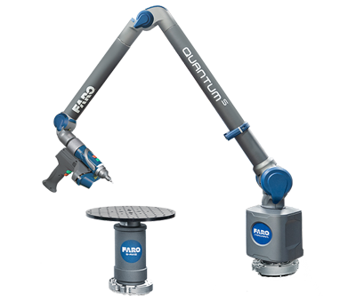

Figure Faro Laser Arm

## Geomagic Software

Geomagic is a brand of 3D systems. A professional engineering software with an emphasis on computer aided design. It is used for 3D scanning, and voxel-based modeling with haptic input. It was founded in 1997 by Ping Fu and Herbert Edelsbrunner. The geomagic software comes with 3D Scanning systems, 3D Design Software, and 3D Inspection and metrology software. We use it to work with the Faroarm Laser scanner and to also sample the cloud points to reduce the number of points in it.

## Cloud points

Cloud Points are essentially a set of data points on the surface of the body, which are produced through 3D scanners. Cloud Points serve various purposes from multiple visualizations, animation, to metrology, 3D printing of surfaces and many other applications. Once the sampled points are obtained; we can then import it into the CAD software which will allow us to produce an accurate drawing. The process of converting an object into a set of cloud points can be done directly. However, they are often converted to models of polygon or triangular meshes. They are usually converted to CAD models. This process of conversion is referred to as surface reconstruction (Raffo, Barrowclough and Muntingh, 2018)

.

# Model – 1 (Reconstruction by Umayr Jahagirdar)

## Introduction to Model Scanning

The entire process of reverse engineering starts with scanning the 3D object for reconstruction. In the metrology lab we have two different methods for scanning of the object. One tool uses cameras to take snaps of the object from different sides, by rotating the platform on which the object is placed. The laser tool (Faroarm) is used by moving the handheld scanner across the surface of the object. Unlike the camera sensor which uses external light to find the details on the surface, the laser sensor emits its own light and hence, provides better accuracy. Therefore, the laser tool is selected, and the object is fixed in place while all surfaces are scanned using this tool. This method returns over fifty-thousand points, as the laser captures all details of the surface. While it gives us a more accurate description the CAD software cannot function with so many points. To reduce the number of points, we use a sampling technique through which we reduce the number of points to about two thousand points.

## Detailed Model Reconstruction Methodology

**Step 1**: Importing Points from ASCII file

The first step in the process is importing a set of cloud points from an ASCII file. These points give a very ambiguous outline of what the surface will look like. As you can see in the figure below. The cloud points in this case contain excessive number of points, hence these must be reduced by using sampling tool in Geomagic software. We reduce the number points to 2000 which gives us a clear representation of the boundaries and surfaces of the model.

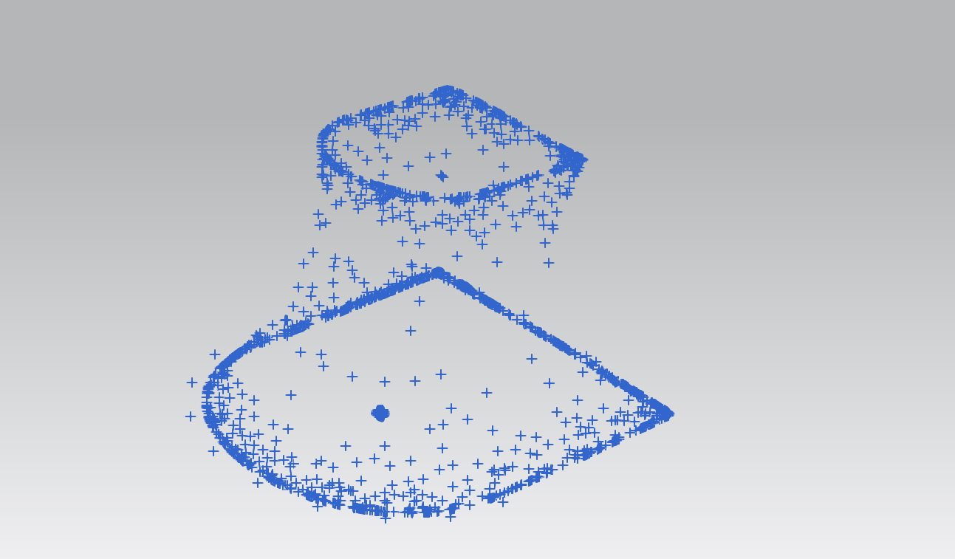

Figure Cloud Points

**Step 2:** Drawing Curves using the cloud points as reference

The next step involves connecting the points accurately to determine the shape of the object. This involves selecting all points which are on the outside surface and are important to create a skeletal structure of the object. We require two sets of curves, a vertical set of curves called primary curves and a horizontal set of curves called guide curves. Once done correctly it gives us an outline of all the curves necessary to create the sheet surface of the object. This can be seen in the figure below.

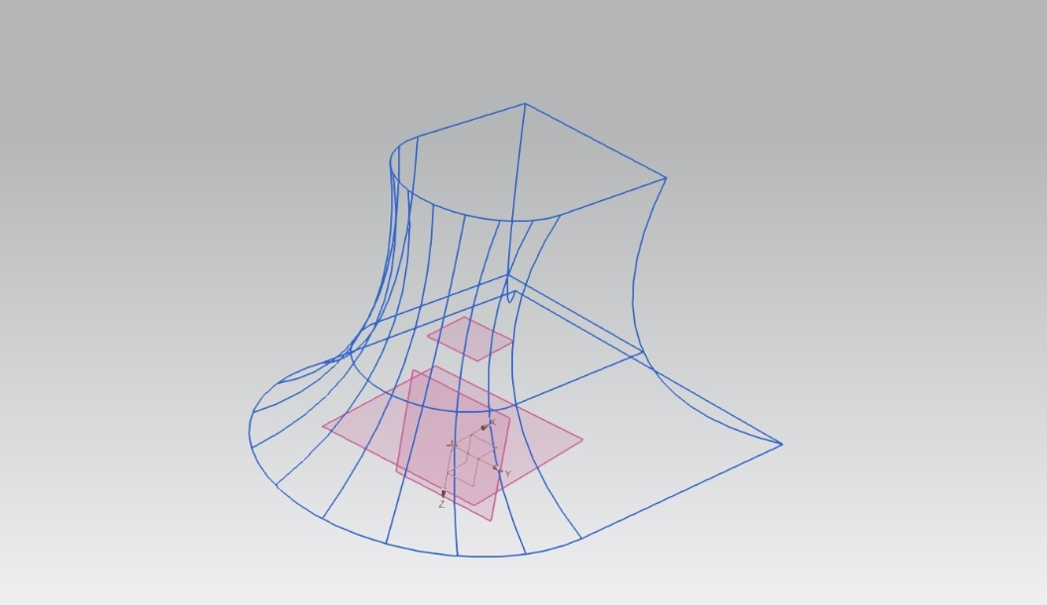

Figure Studio Splines

**Step 3:** Creating Sheets Surface using Spline Curves

After determining the points, we need to use the studio surface tool. We select certain curves to act as boundaries to a section of the object. The curves are drawn between the primary set of curves while using the guide curves to help position the surface along the spline. The primary curves in my model are all the vertical splines and the horizontal splines are used as the guiding curves. After selecting them, the software helps us create the studio surface sheets. The sheets give the skeletal structure of the object a surface, as seen in figure below.

**Step 4:** Converting sheets into single body using Combine.

At this step, we have multiple sheets which can be combined into a single body. This step is essential for smooth application of the Thicken function (used in **Step 5**). This was found when NX encountered an error while trying to apply the thicken function.

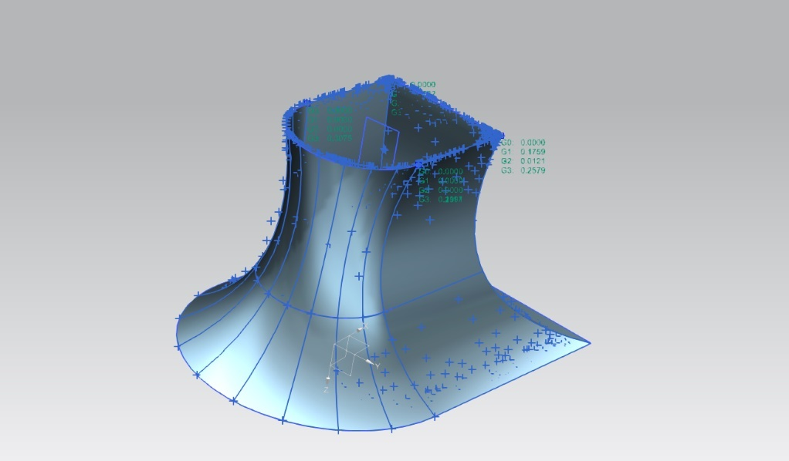

Figure Final Model

**Step 5:** Creating a solid body from the Combined Sheets.

The combined sheets from a single body but needs the thicken function to create a solid body with a measurable thickness. Here, we increase the thickness to 1.3 mm to create the final Solid CAD Model from cloud points.



## Validation of Model – 1 by Umayr Jahagirdar

After successfully recreating the scanned model as a CAD drawing, we need to compare the dimensions of the CAD model – 1 to the measurements taken from the CMM machine available at the Metrology Lab. As seen in the figure below, we compare the same dimension on both the models. The model is within the expected tolerances.

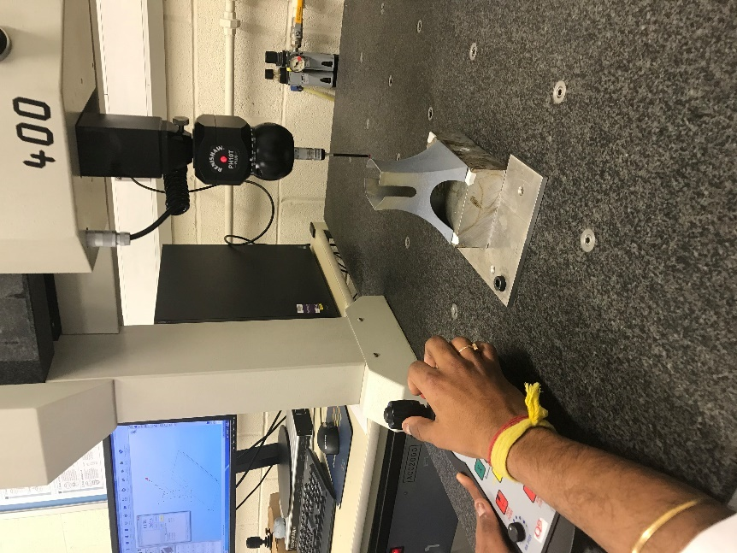

Figure CMM Measuring in Lab

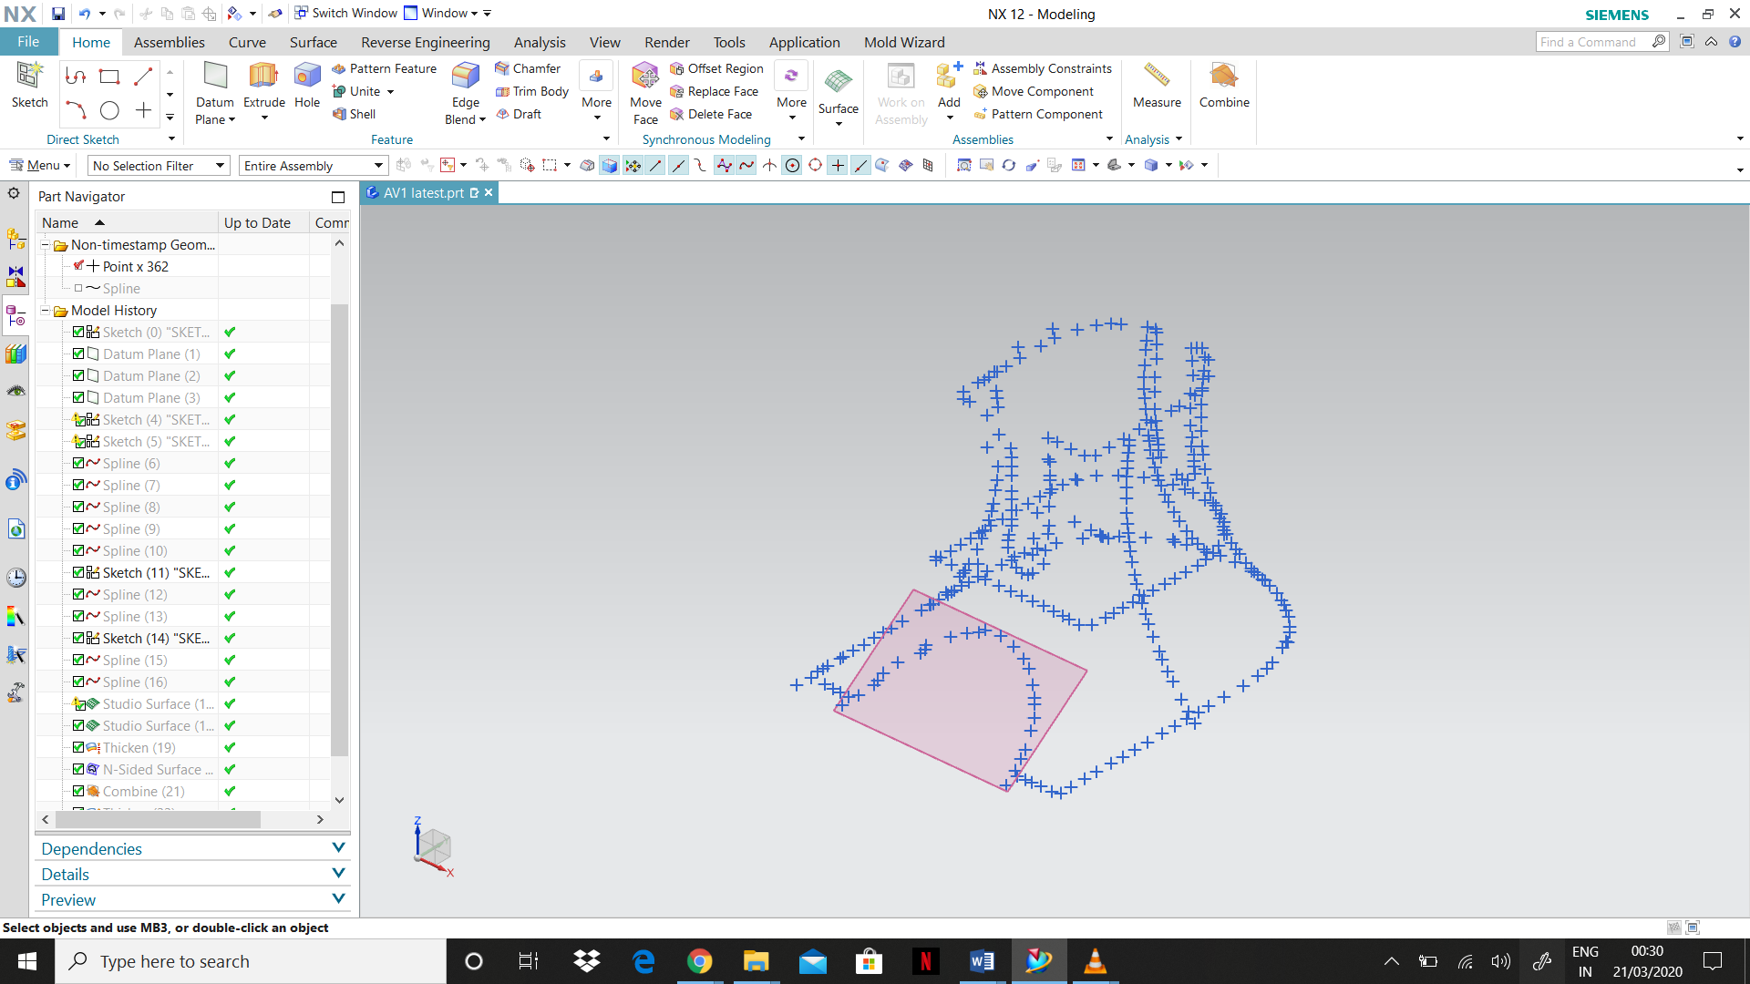

Figure CMM Data Points

The curve continuity analysis tool is used to check the surface continuity and smoothness of the curves. We also use the reflection analysis to check on the surface quality. At this level we require a G3 continuity which is the best surface quality possible, with all curved surfaces having uniform thickness and consistency. The figure below shows the curve continuity analysis (left) and the reflection analysis (right).

# Model – 2 (Reconstruction by Sam Johnson)



For our assignment we have chosen model 4 for reconstruction. For my individual design I selected the file with 4000 cloud data points because it provides adequate information for accurate surface reconstruction.

## Detailed Model Reconstruction Methodology

**Step 1**

After importing the cloud points in the NX software, I created three vertical data planes at the bottom, middle and top sections. Then started a new sketch and by using studio spline I joined the data points using the bottom data plane as reference. Constrain all the points in the spline to the bottom data plane to ensure that the spline does not get misaligned while editing.

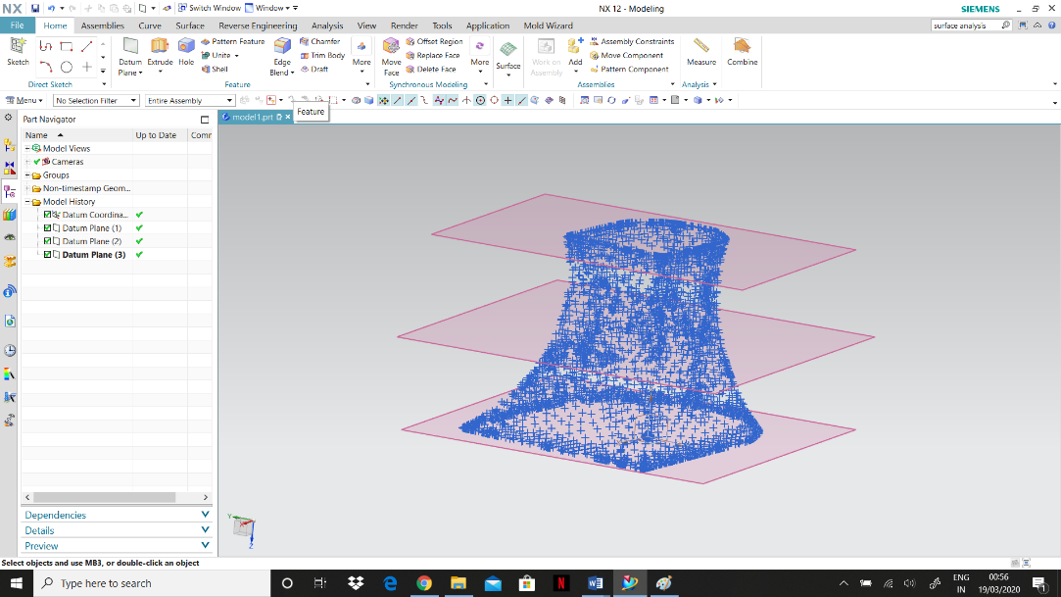

Figure Cloud Points and Daitum Planes

**Step 2**

Next using the X form function we can edit the spline to match the exact shape of the cloud data points. After that a new sketch is started and the same process is done at the middle and the top data planes. I used three separate sketches for the purpose of easier editing and alterations.

**Step 3**

For the vertical section I used five splines in total. I drew two splines on the front side along the curved edges by joining the data points and made sure that these splines intersected with all the three horizontal splines. On the backside I drew three more splines appropriately using the same method. After that I used X form function to modify the splines according to the required shape.

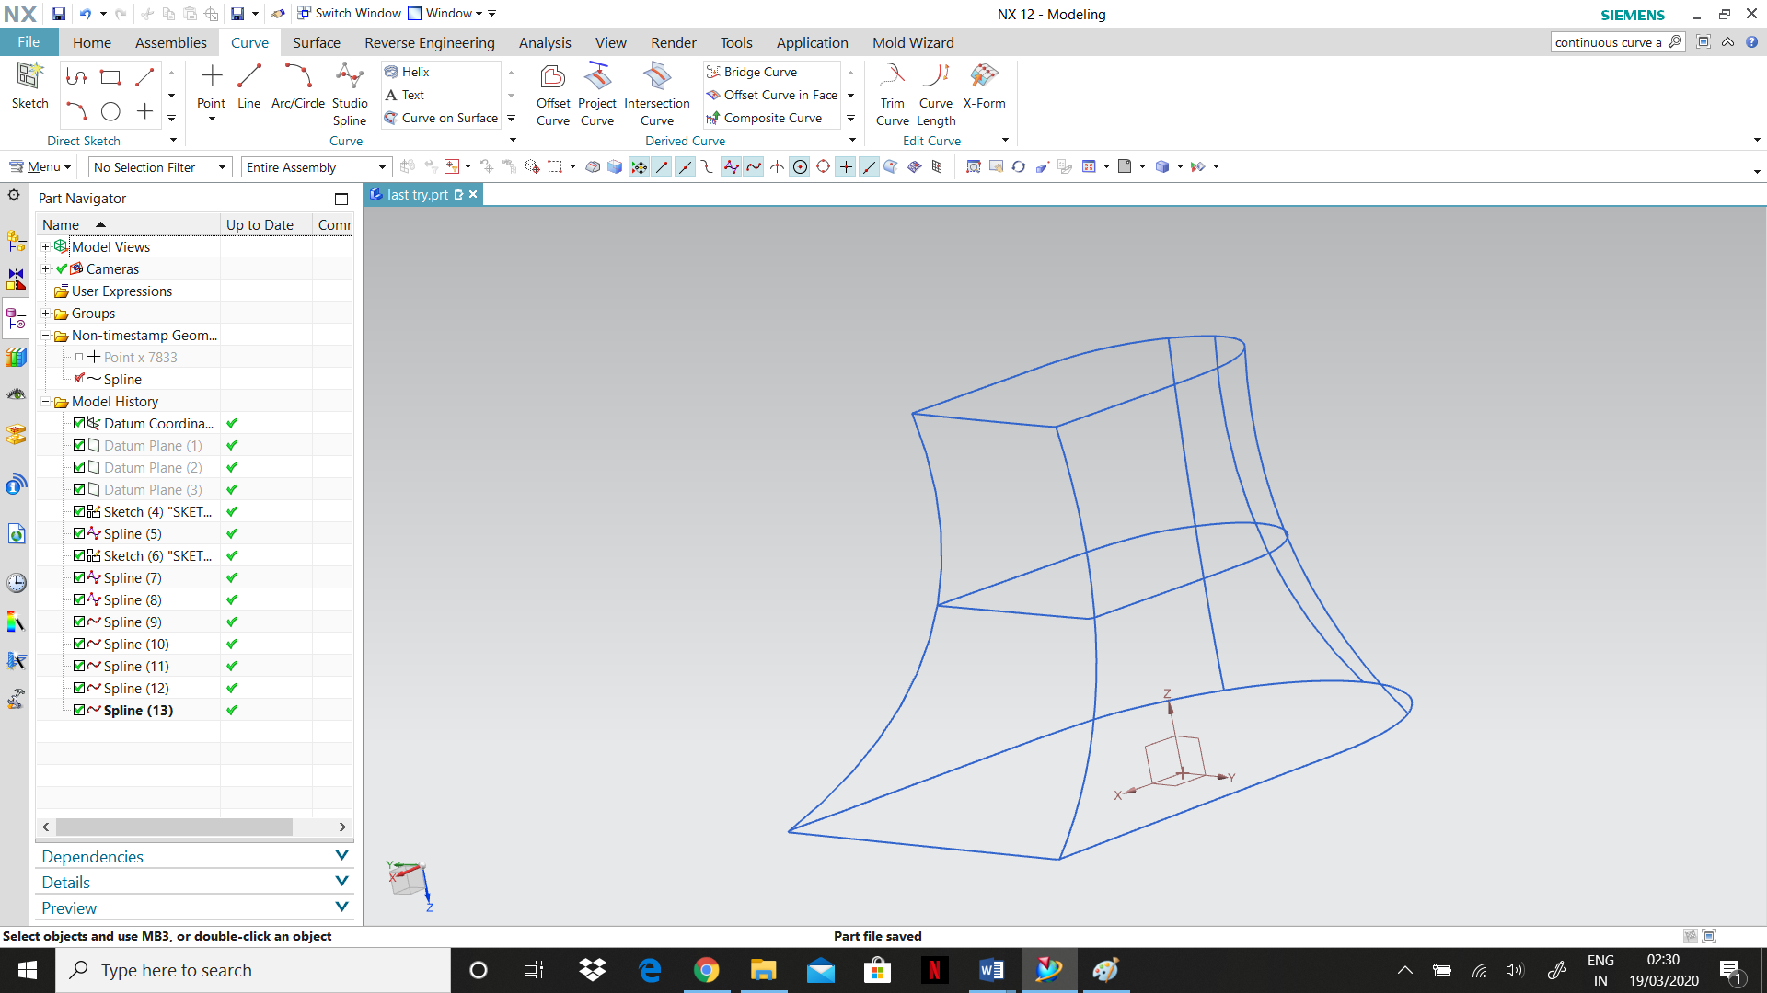

Figure Studio Splines

**Step 4**

The next step is the construction of the surface using the studio surface function. Using the vertical splines as the primary curve, a sheet body is created. This sheet body is then guided through the horizontal splines to generate the required shape.

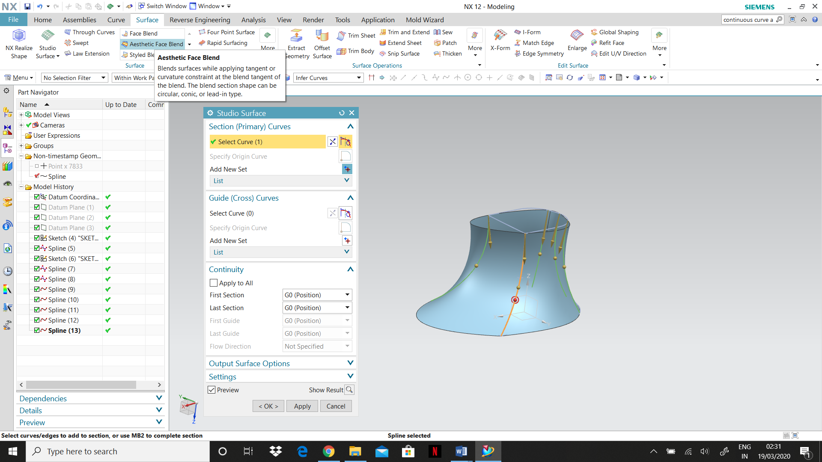

Figure Studio Surface without guide curves

## Conclusion of Model - 2 by Sam Johnson

Using the CMM machine, we obtained the proper dimensions of the solid. From the cloud points generated, we can obtain the dimensions of the cut openings in the object. Using this a similar cut opening is made on our CAD design. In order to create a core and cavity surface, one of the openings must be closed. So, using the N-sided function, we closed the top opening. Before thickening the faces, the combine function was used to make to patch and the created object as a single object. Finally, the thicken function was used to convert the sheet object into a solid.

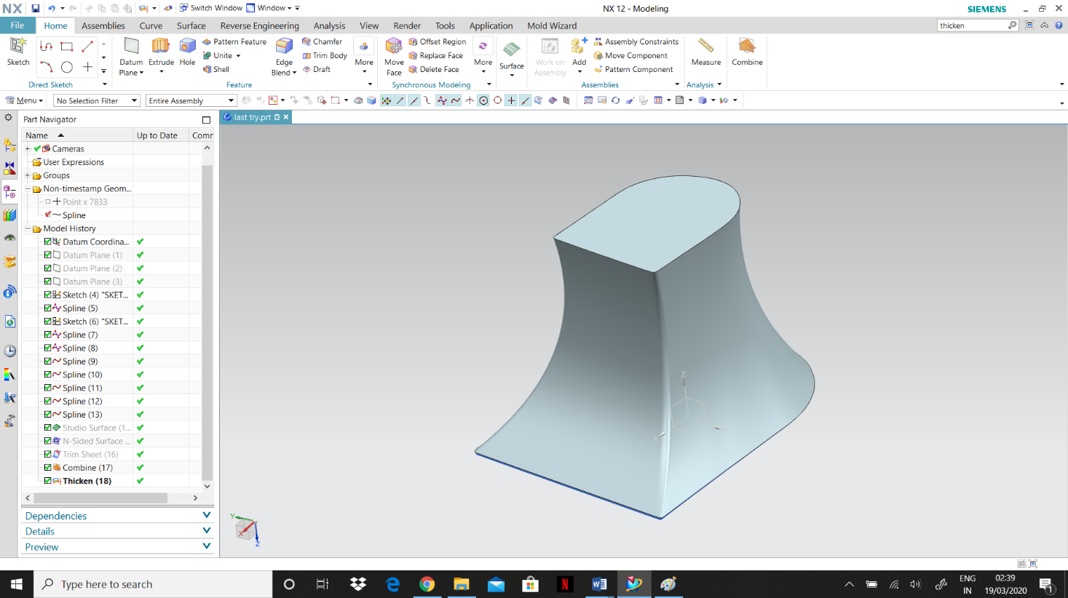

Figure Studio Surface with guide curves

# Comparing Models

## Comparing Methodologies

As observed from section 3 & 4, the two models created are similar looking as the general steps to create a CAD drawing from cloud points remains the same. Hence, in the following section we discuss only the differences between the two models.

Model – 1 is created by using a cloud point file with 2000 points. The lesser number of points will not slow down the CAD software as it has lesser processing to perform. With fewer points, I have a clearer view of the boundaries and curves of the surface. Model – 2 uses the same set of cloud points but in this case, they are sampled to get a higher 4000 points. This increases ambiguity in certain areas as, multiple points are present in closer proximity. However, with extra points we can have the luxury of choosing from multiple points according to our design needs.

Both models use a similar approach of drawing vertical and horizontal splines to obtain studio surfaces between them. However, the choosing of primary and guide curves is where they differ. Model – 1 uses the vertical splines as primary curves and the horizontal splines as the guiding curves. This allows for a smoother curved surface with better continuity. However, by design the radius of the vertical curves are quite high. This leads to problems where surfaces intersect with each other, when the Thicken tool is applied.

## Result

* Model – 1 is created to be as accurate and precise to the original scanned object. Special attention is payed to ensure the curves are identical to the scanned model. This is achieved by adding extra splines around all sections of the surface to guide the studio surface sheets. When compared with CMM measurements we find the model to be identical to the scanned object with minor tolerance for error.
* Model – 2 is created keeping injection moulding in mind. In section 6, we are required to design and simulate the injection molding process. For this purpose, we need a model which is a single continuous body. The splines are drawn such that the curves can be created as a single sheet by using the vertical splines as guides. This ensures that once the top surface is closed, we are left with a single continuous body, which makes the injection molding process smoother to implement.

Comparing the two models, we can clearly observe that creating the perfect design and ensuring its practically possible to manufacture are mutually exclusive. The perfect and accurate design of Model – 1 is not compatible with the injection molding process as the draft angles are wrong and we would not be able to eject the piece from the mold without further complications. However, Model – 2, is similarly accurate with slightly higher tolerance for error but, can be used for mold creation. Its design has been created with keeping injection molding in mind. Hence, despite Model – 1 being more accurate, we prefer Model – 2 for injection molding to ensure smooth operation of injection molding process.

# Mold Design and Validation

## Introduction to Injection Molding and Mold Design

Advanced computer aided manufacturing allows us to run the entire simulation of injection molding. Everything from the flow simulation to the ejection of the part from the mold can be simulated before ever going to the manufacturing phase. All specifications and parameters of the injection molding machine can be imported into the CAD software, to ensure there is no collision and the manufacturing process develops without any glitches or clashes.

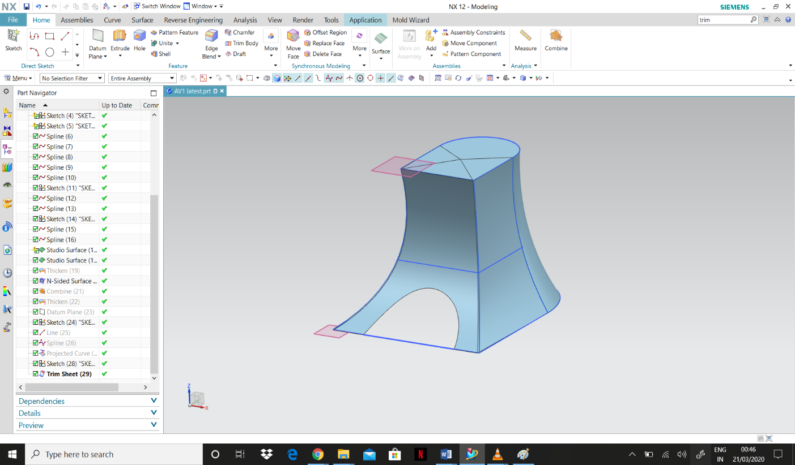

Figure Initialsing Mold Wizard

## Design of Mold Cavity and Core

The next process is the designing of the Core and cavity mold using Mold Wizard.

* First initialize the project and assign a material. In this case we select ABS plastic.

* Perform mold design validation and check for draft angles and undercuts. Then we calculate the wall thickness by using the Check Wall Thickness tool. Before moving to the next step save all the part files.

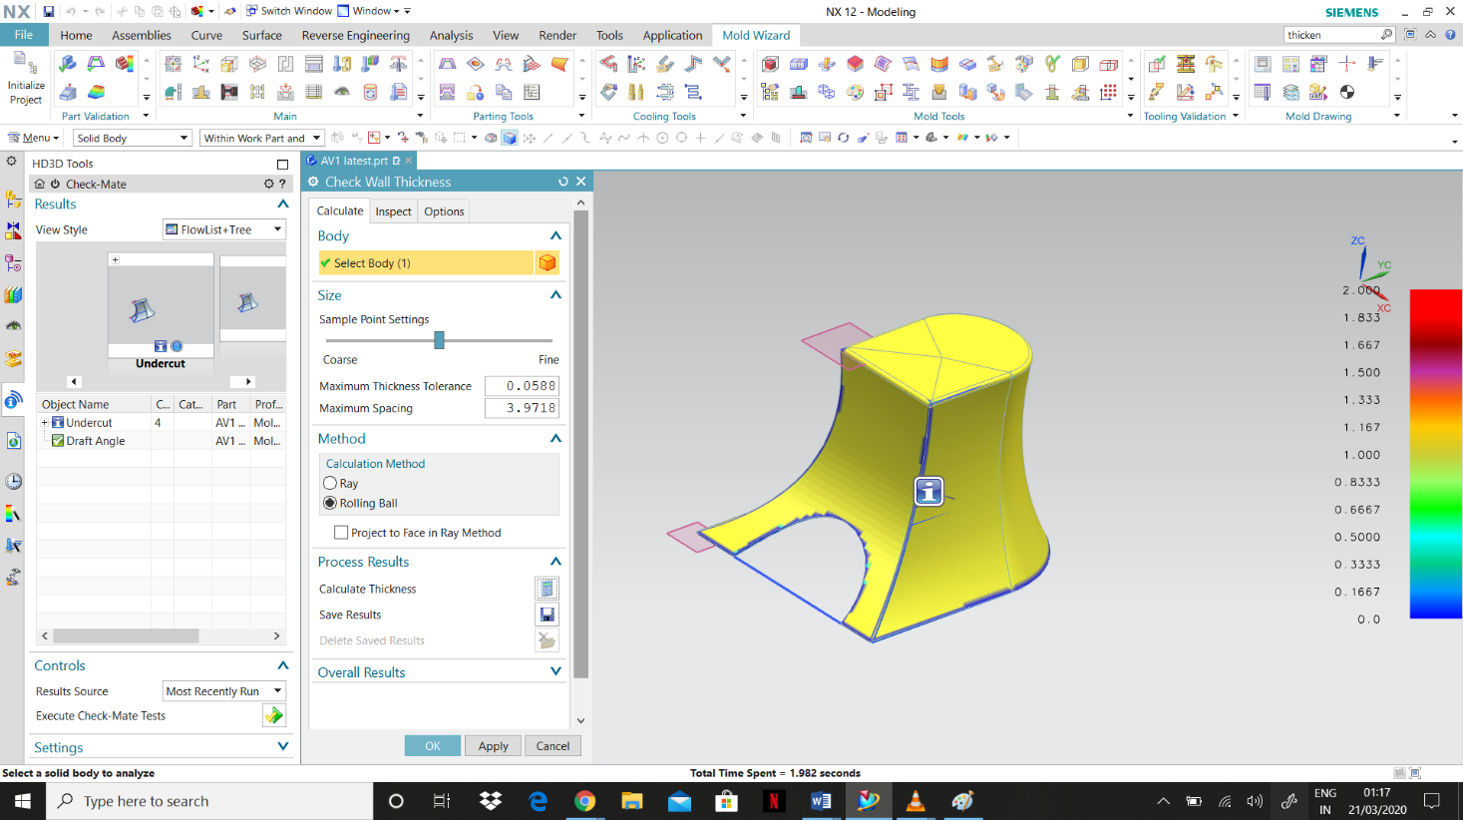

Figure Thickness Analysis

.

* To run flow analysis, we open the mold part file from the saved location. Using the Run Flow Analysis tool, we specify a gate point for material injection. We can then display the flow analysis, observing the material being injected into the designed solid mold.

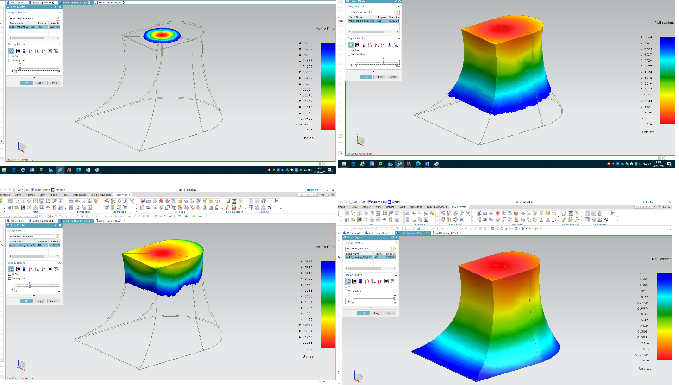

Figure Run Fllow Simulation

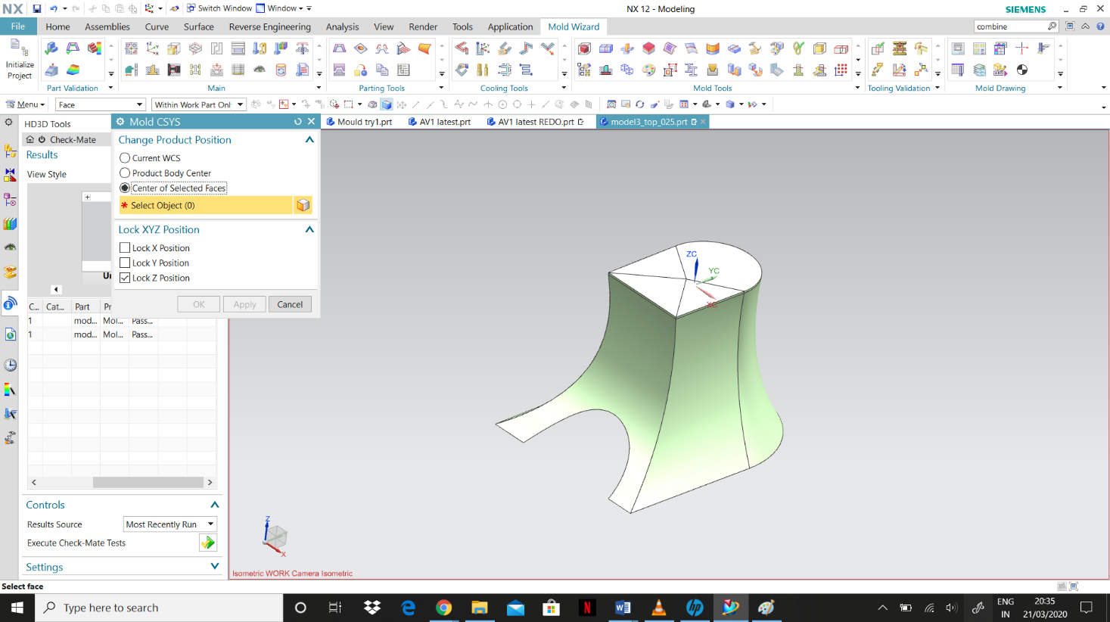

Figure Mold CSYS Positioning

* After that we re-position the mold CSYS to the center of the object and update the work piece. Now, we go to check regions under parting tools then calculate the product body and assign the core and cavity surfaces. Set specific colors to differentiate the core and cavity faces.

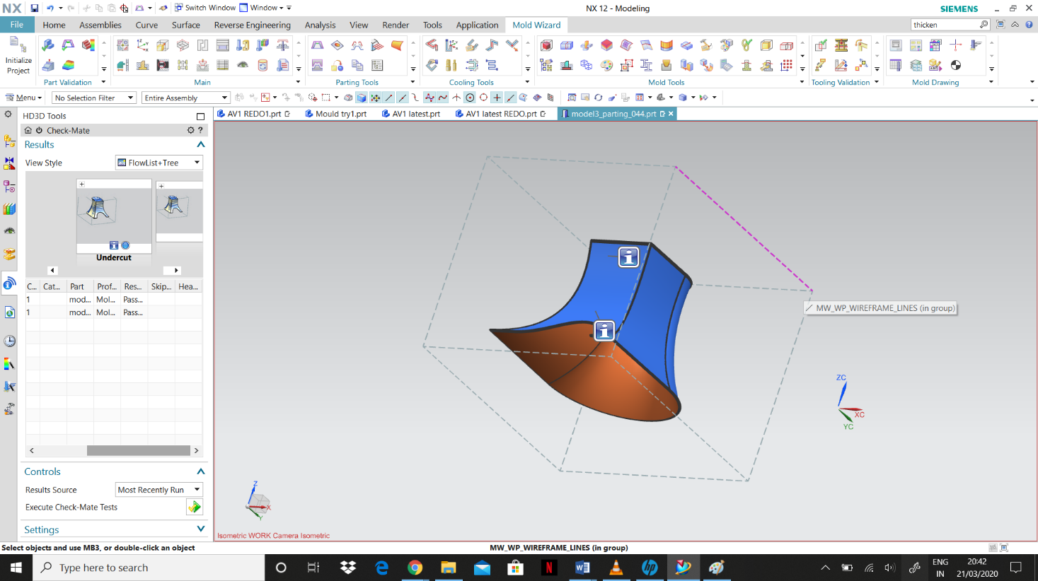

Figure Define cavity and Core

* The next step is to, define regions function to create regions and parting lines and check if the cavity and core regions are declared properly. Make sure that the undefined faces are zero. Now we can design the parting surface. Using edit parting surface, we create 2 parting segments. Draw 2 guidelines at the ends of the cut opening on the front surface which becomes the segment 1. Segment 2 is the rest of the flat surface. With the guided lines, the parting surface is created. We can alter the size of the parting surface but make sure it is larger than the work piece

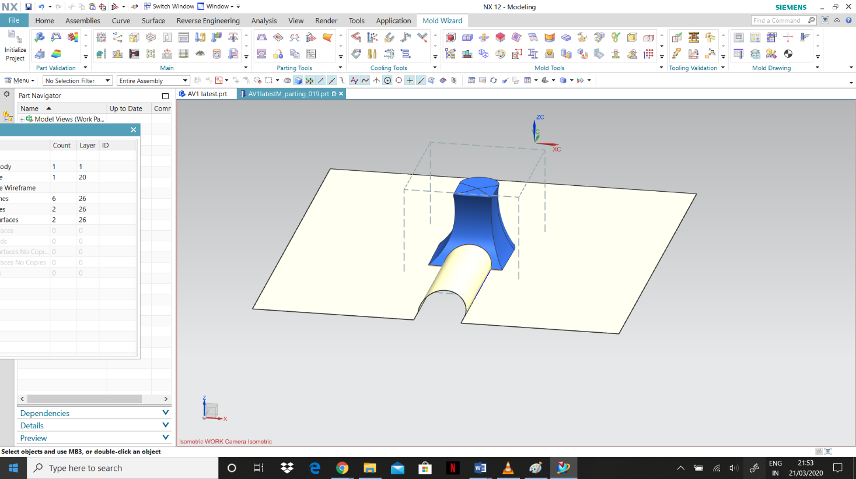

Figure Parting Surface

* Finally, to generate the mold for the core and cavity use define core and cavity function, select all regions and apply. The separate molds for the core and cavity will be displayed.

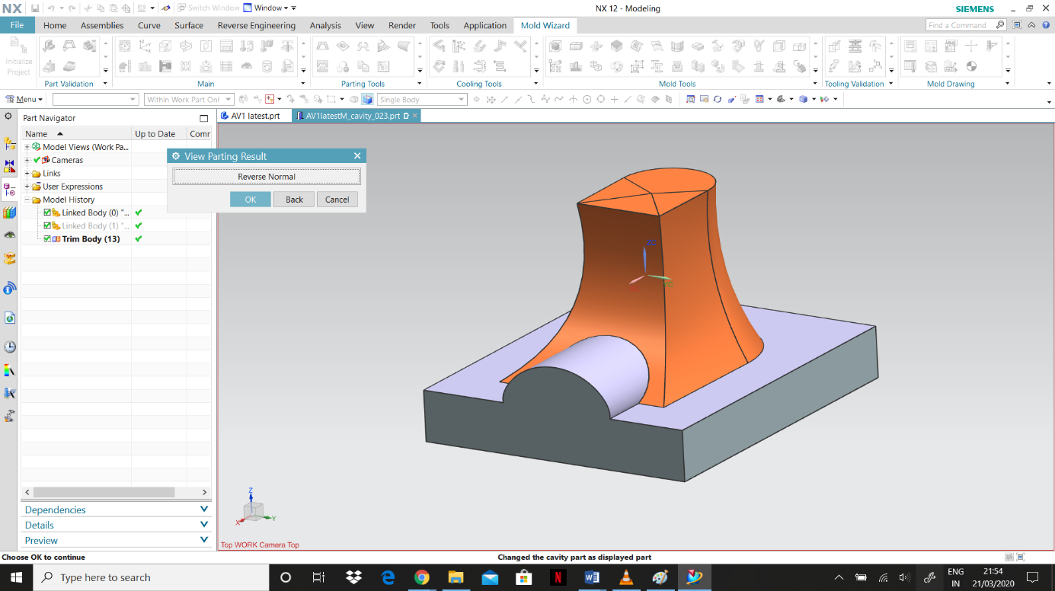

Figure Above: Mold Core; Below Mold Cavity

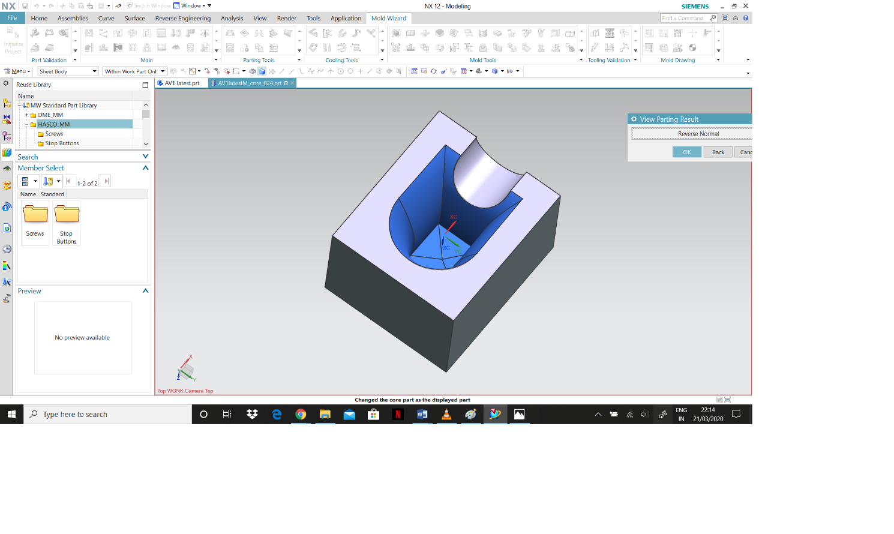

|  |  |
| --- | --- |
| Tools | function |
| Mold Design Validation | Validates injection model and mold design details |
| Check Wall Thickness | Analysis the wall thickness of the part |
| Run Flow Analysis | Design gate point and runs flow analysis |
| Display flow analysis result | Imports and displays flow analysis result in the graphic window |
| Mold CSYS | Repositioning the product component |
| Workpiece | Define the insert workpiece for core and cavity |
| Check regions | Performs region analysis |
| Define regions | Defines regions from faces of the product and creates parting lines |
| Design Parting Surface | Create or edit parting surface |
| Define cavity and core | Sews regions, paring and patched sheet |
| Mold base Library | Adds and configures mold bases |
| Standard Part Library | Adds and edits standard part |
| Design Ejector Pins | Adds and edits ejector pins |
| Ejector Pin Post Processing | Trims the ejector pins |
| Pattern Channel | Creates the cooling channel |
| Extend Channel | Extends Channel to the boundary |
| Define Channel | Selects the type of cooling |
| Cooling Circuits | Combines cooling channel into a circuit |
| Design fill | Creates gates and runners |
| Runners | Creates paths and runners |
| Pre-processing motion | Sets motion for different parts |
| Run Simulation | Animates the model |

*Table 1 : tools used in injection molding*

## Mold Base Library

After creating the core and cavity mold we add the assembly using the Mold Base Library. In the mold base library, we select 2A from the member select and the assembly with the mold design will be generated.

The next step is the addition of all the standard parts available in the Mold Wizard Standard Part Library.

1. **Locating Ring**

First, we insert the locating ring with the screws. The locating ring is used to locate the orifice of the sprue. It is always located concentric with the sprue to prevent any misalignment with the machine’s nozzle.

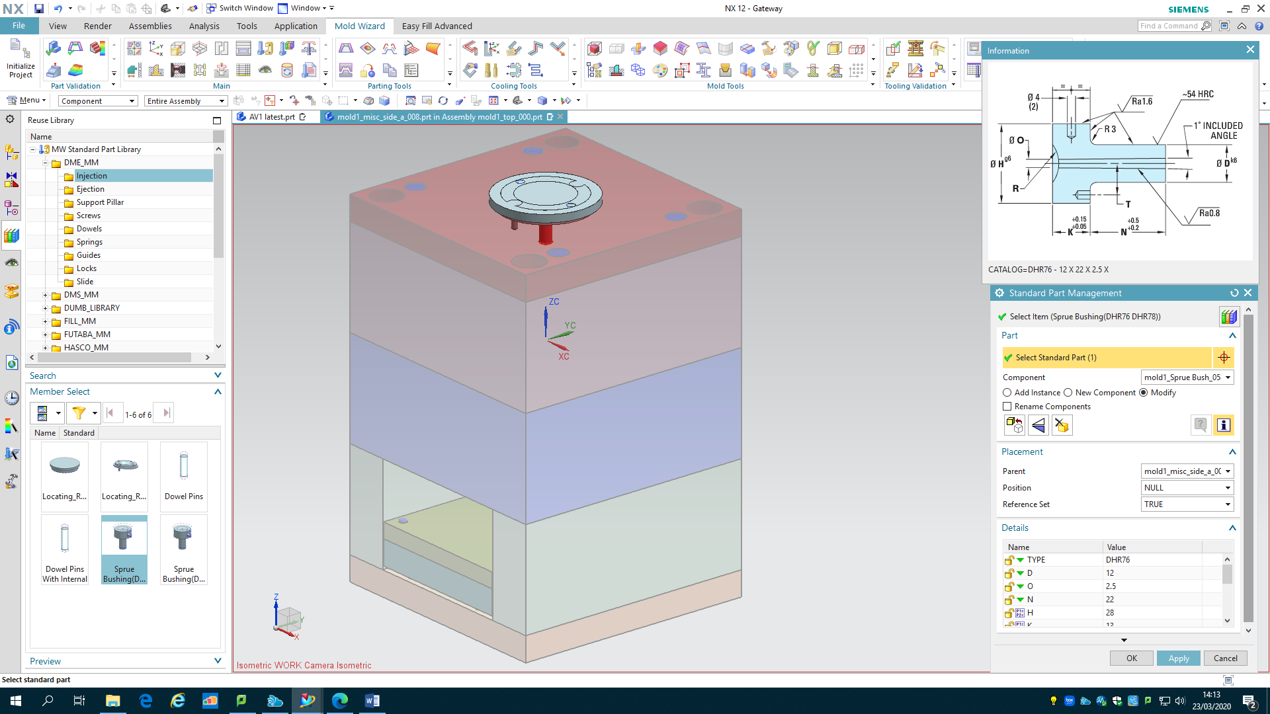

Figure Mold Base Library- Locating ring, Sprue

1. **Sprue**

Next adding the sprue. The sprue is basically the channel through which the material is poured to form the mold.

1. **Designing Ejector Pins**

Then we go to Design Ejector Pins and select specific points on the design surface for the position of the ejector pins. Chose the appropriate length and the diameter of the ejector pins. We have assigned 4 specific points and created 4 ejector pins. The ejector pins are trimmed at specific length, so that they do not cause any obstruction with the mold parts. This can be done using the ejector pin post processing function where we can adjust length, trim or extend the pins according to the requirement. (add more data/nos. after tooling)

1. **Cooling Channel**

The following step is to design the cooling system for which we can use the functions under Cooling tools. First to create the path for the cooling channel, we open pattern channel and assign a new plane at a specific distance. Now you can draw a sketch for the cooling system. The diameter of the cooling channel is altered to the desired specification. Use the Extend channel function to extend the cooling channel to the outer boundary for the molds. To select the type of cooling system, use the define channel function where you can select between air, water or oil cooled system. Then use the cooling circuit function to specify the direction of flow of the cooling material through the channel. Finally go to Concept Design, select all the displayed components and apply. This will automatically generate the inlet and outlet ports for the cooling channel.

1. **Gates and Runners**

The next step is to create gates and runners using the design fill and runner functions. To create the runner, we first draw a line from the sprue to the object and the runner is created using this line as reference. Then add a gate to the end of the runner. Adjust the dimensions of the runner and gate so that the gate touches the body surface.

1. **Pockets**

Now that we have created all the components, the next step is to create the pockets. The function of pockets is to modify a body with projections of a section. In the Siemens NX modeling, we can create a pocket following: Cylindrical, rectangular, general by pocket command. It is used to remove material from a solid body or modifies a sheet body with faces made by projecting a section along a vector. Now, click on pocket function, select the entire body and the objects and apply.

## Analysis and Simulation of Injection mold design.

Finally, we can move on to the motion process. If we go to the Preprocess Motion function and select mount component, it will display all the moving, fixed, ejection and other components. Select and apply all the components. For the last step use Run Simulation and you can see the simulation of the whole injection molding process where the object is created and ejected out of the assembly.

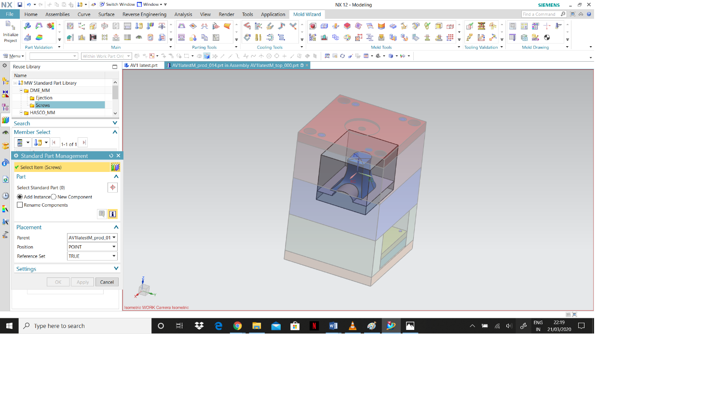

Figure Final Simulation

# CONCLUSION AND RECOMMENDATIONS

The overview of the entire process is, first the object was scanned, and cloud points were generated. After that using the cloud data points a CAD design was made in the Siemens NX software. Finally mold design and validation was done for injection molding. We measured the dimensions of the original object by generating data points using the CMM and compared it with our design to check the accuracy.

Working on this assignment helped us to gain knowledge about the Siemens NX software and about the machines we got to work with in the laboratory. Especially, working with the Faro Laser Scanner and the Coordinate Measuring Machine (CMM) we were able to get a practical experience as we had the opportunity to handle all the equipment and understand how the data points are generated for a given model. Then while working on the software we learned different freeform surface modelling techniques to reverse engineer the required design form the data points that we generated through the Faro Laser Scanner and the CMM. After designing the CAD model, we worked on manufacturing the design using injection molding. We were able to understand the process for designing and validating the molds for our CAD model. Observing the run flow analysis, gave us an understanding of how the material is injected and flows to form the object.

Overall, we have gained knowledge on how to reverse engineer an object and manufacture it. Our chosen model has complications in the injection molding process because of its undercut angle. This will prevent the object from being ejected out of the mold. This problem helped us in understanding the injection molding process better. It made us analyze the process and study more about the specifications needed for injection molding.

The development of computers has allowed for easier communication between the software engineer and the technician. Earlier, one had to print and send a 2D drawing, and the technician would have to figure out the differences between the 2D and 3D viewing by themselves. These new developments in reverse engineering and injection molding technology have allowed for a successful and efficient use of resources and effective execution of scanning and printing a 3D model of an object. Another advantage of CAD is that now we can simulate the entire process on the computer before we start the machining process. We therefore can be made aware of any and every possible mistake before the actual manufacturing process begins.

To conclude during this project, we learned that computer aided technology has come a long way and has made it easier to process, transfer and move to manufacturing process. The entire manufacturing can be simulated and modified on the CAD software itself. All design and manufacturing decisions can be made on the software itself without a need for physical trial and error.

For future recommendations, Fabrication of stainless-steel based composite by metal injection molding (Nayak et al., 2018) seems particularly important, as we now can create complicated and delicate metal parts without wasting of metal. This method provides incredibly strong objects which can be manufactured in bulk with very high efficiency. With metal injection molding we can also consider the use of particulate injection molding for fabrication of sports and leisure equipment from titanium metals (Ewart, 2018).

# REFERENCES

Veeresh Nayak, C. et al., 2018. Fabrication of stainless-steel based composite by metal injection moulding. Materials Today: Proceedings, 5(2), pp.6805–6814.

Paul D. Ewart, 2018. The Use of Particulate Injection Moulding for Fabrication of Sports and Leisure Equipment from Titanium Metals. *Proceedings*, 2(6), p.254.

Raffo, A., Barrowclough, O.J.D. & Muntingh, G., 2018. Reverse engineering of CAD models via clustering and approximate implicitization.

Stănăşel Iulian et al., 2018. Reverse engineering and CAD-CAM approach for manufacturing of spare parts. Case study. MATEC Web of Conferences, 184, p.03004.

Nouri, M. et al., 2015. Comparison of clinical bracket point registration with 3D laser scanner and coordinate measuring machine. Dental Press Journal of Orthodontics, 20(1), pp.59–65.